PD190: Case Presentation

Ammera Kaing Sonia Soto September 6, 2016

Subjective

9yr old female presents for PRRs #14-OL, #J-OL due to incipient caries

MedHx: Non-contributory Dental Hx: history of caries
Dietary: unable to obtain, but likely consists of refined carbohydrates Allergies: NKDA
Social: NSF

Developmental: NSF

Assessment/Diagnosis

CRA: High

- Active lesions present clinically
- Poor oral hygiene

Diagnosis based on clinical exam: incipient caries

- Staining in pits sticky with explorer, not present on radiographs
- Student provider calculated maximum LA based on patient’s weight

Preps
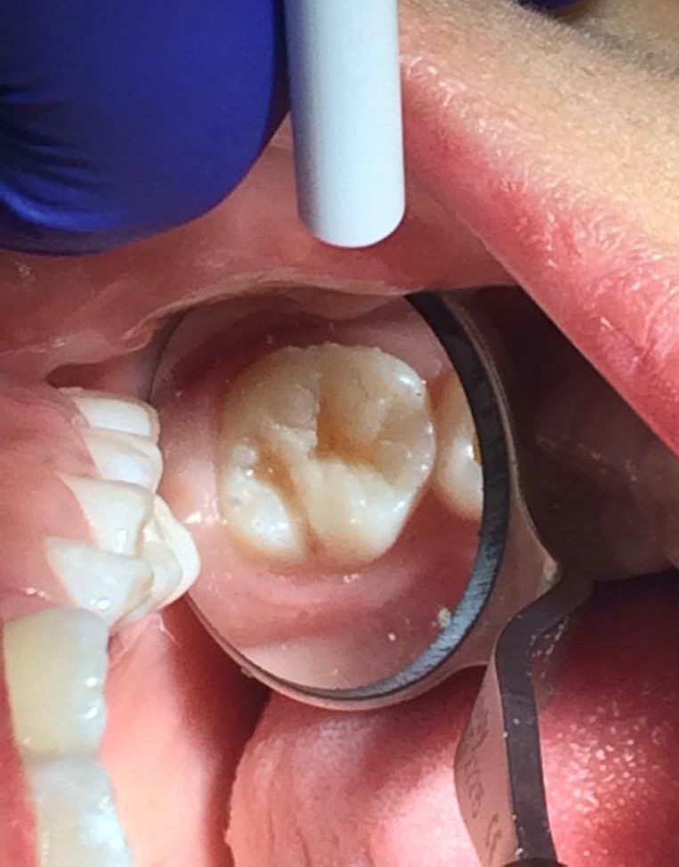
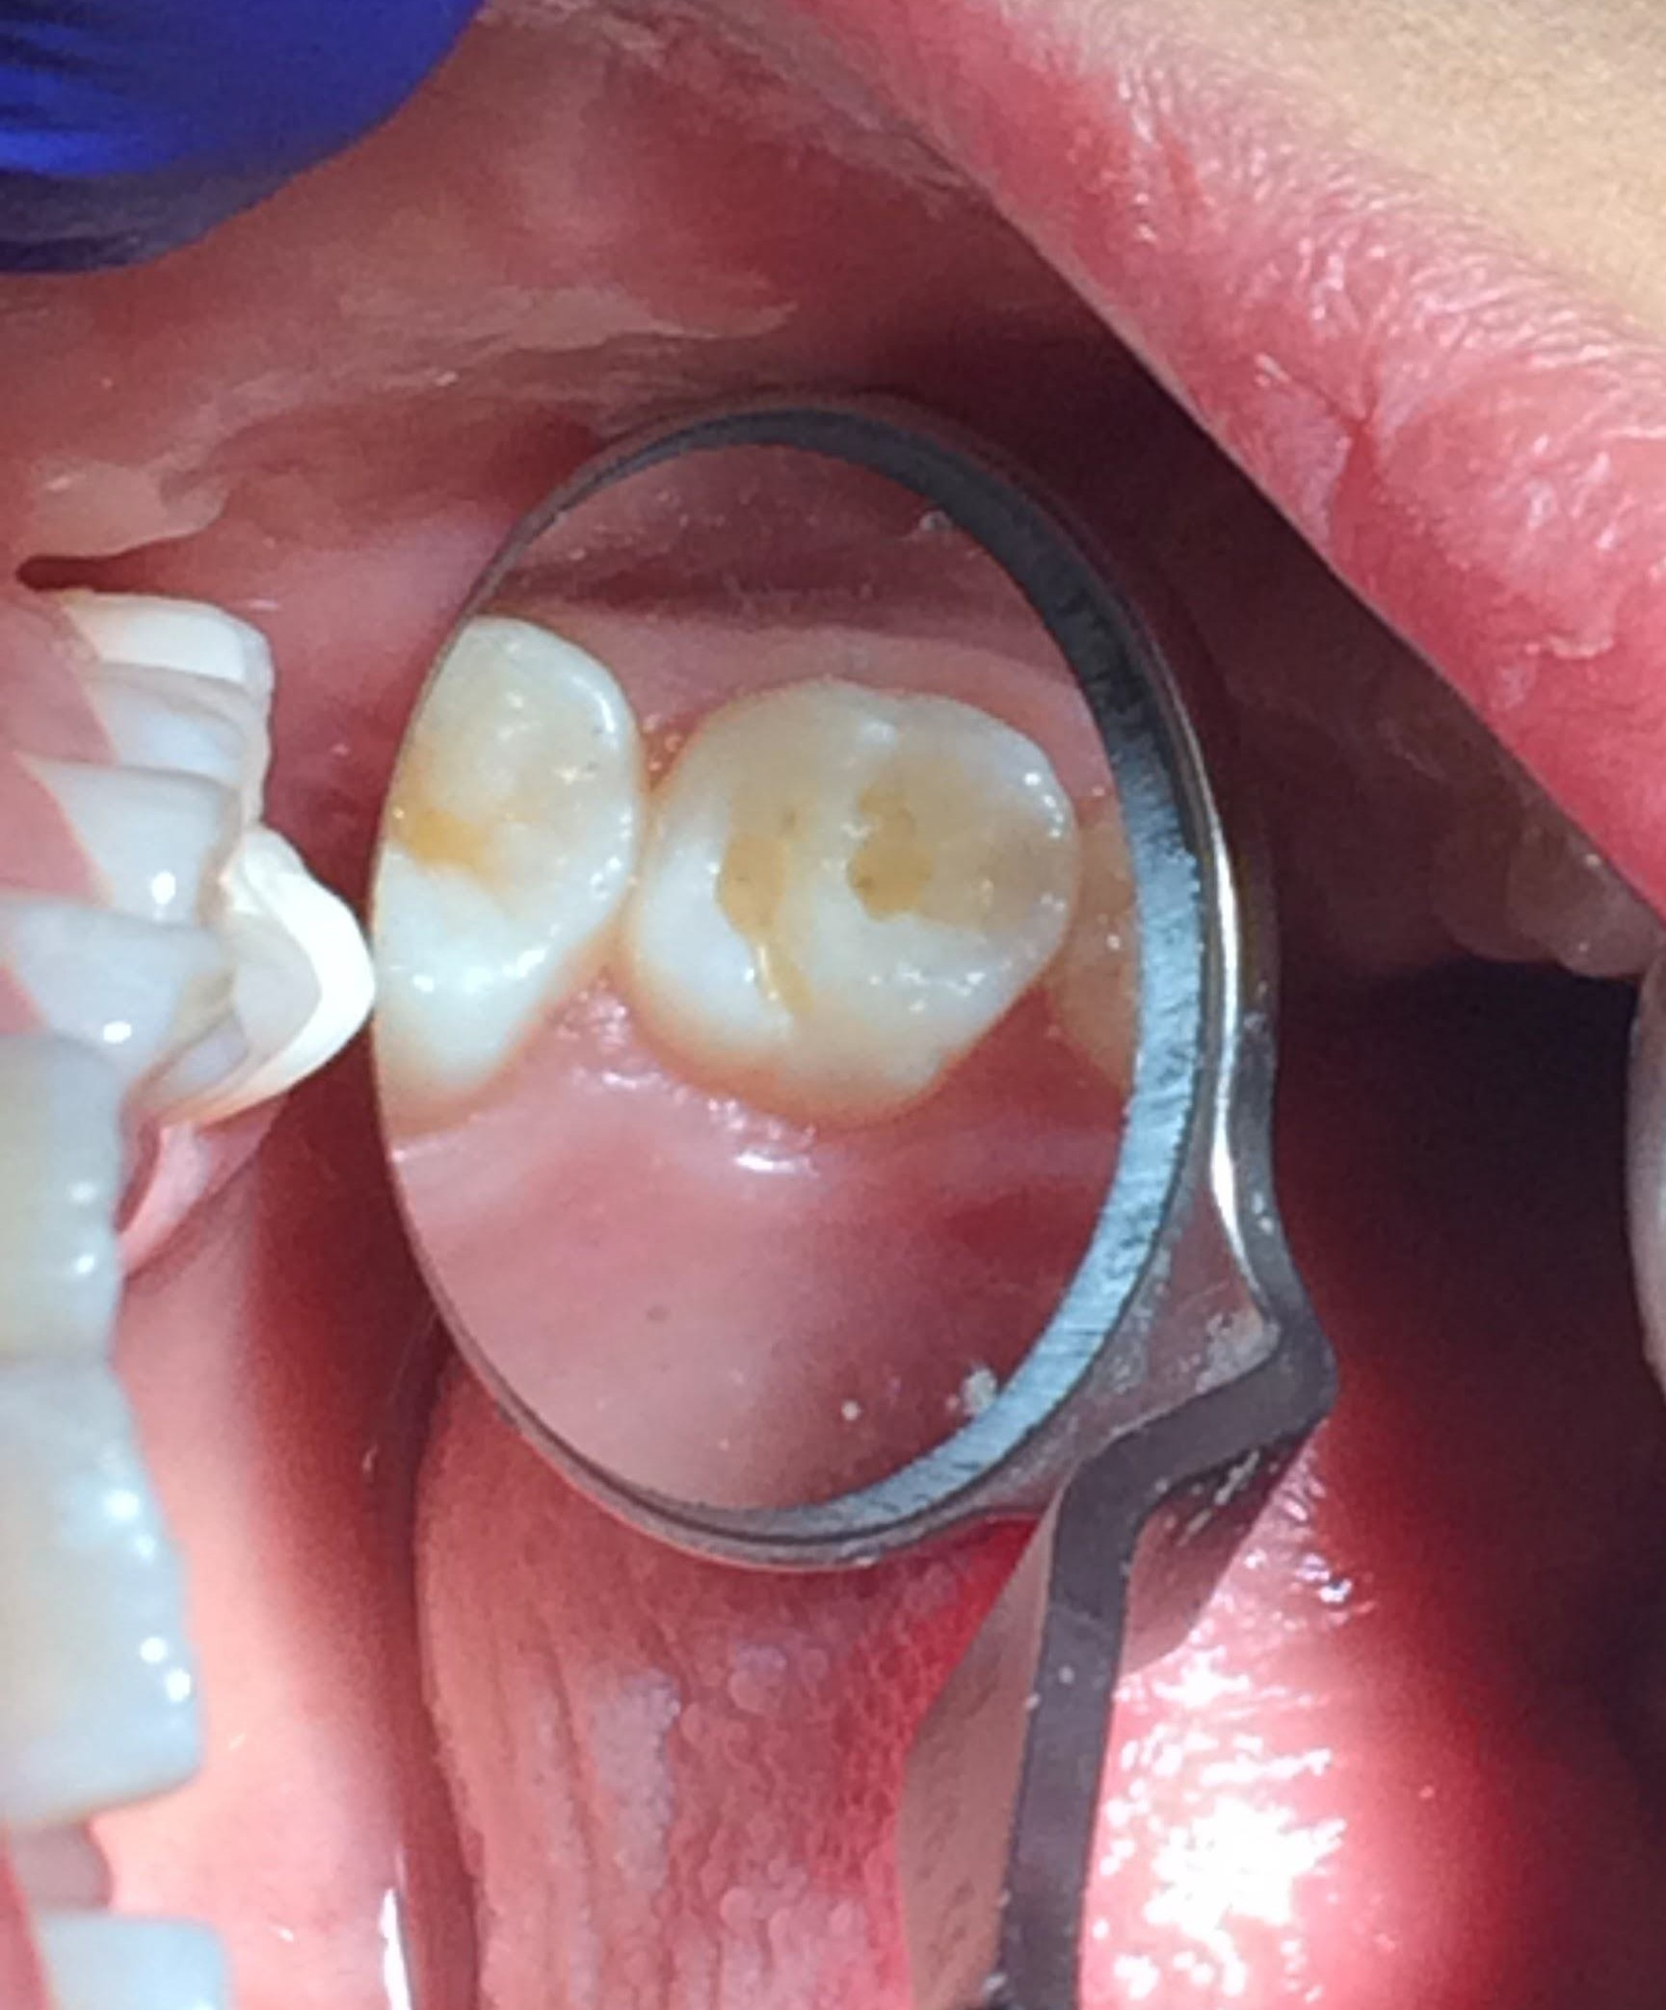
Superficial preps did not require local anesthetic. Cotton rolls and dri angles for isolation

Final Restorations
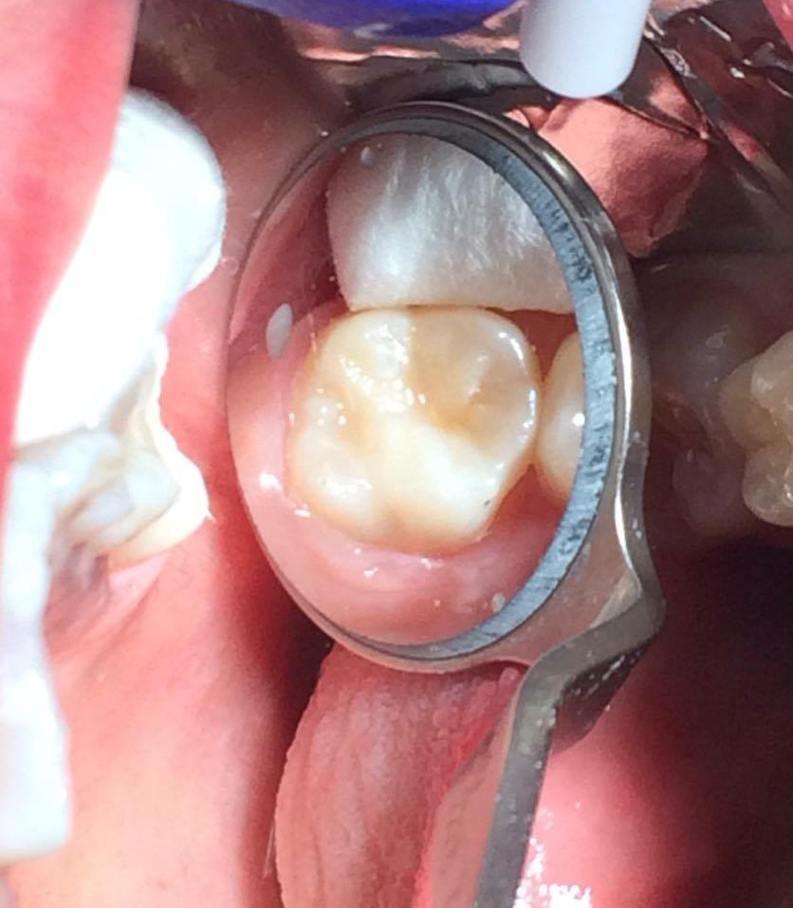
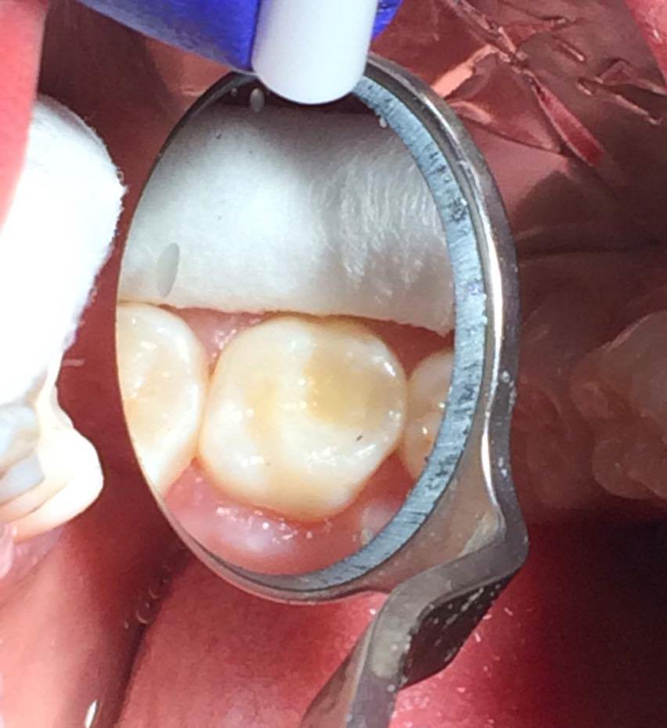

Guidance & Management

Anticipatory Guidance - Middle Childhood

- Injury Prevention/Trauma
- Oral Hygiene Improvement (encourage independent brushing)
- Possible ortho referral for evaluation Management Strategy
- Exams every 3mo
- Fluoride varnish applied every 3-4mo
- Reduce intake of sugar
- Improve OHI

Follow-up Plan

Continue with more frequent (3mo) dental exams, apply F varnish 3-4x a year Medical Significance: none
Nursing Significance: none Main Issues:
- Improving oral hygiene, diet

Good case for interdisciplinary approach: No, this is a straightforward case Advice to parent:
Reduce sugar intake

Help child brush until improvement in hygiene is seen Potential Barriers:
Lack of role model for oral hygiene? Geographic? Economic?

Fluoride Prescription
12) Write a fluoride prescription for this child assuming there is no water fluoridation in the community.

Name: Sally Patient

Address: 123 19th Ave, San Francisco, CA

Age: 9 years

Date: 9/6/16

Rx 1 mg F- in chewable tablet form (2.2 mg NaF), 120 mg F- total, for the prevention of tooth decay

Direction: chew one tablet for one minute, and swish around the mouth, before swallowing, before bed each night.

Warning: Keep bottle out of reach of children. Do not exceed recommended dose.

Refill: x 1

Doctor's signature: ..............

Doctor's license #: ...................

